1 . Ssh to other worker dockers showing a warning related to verification. Same issue occur when we start the cluster

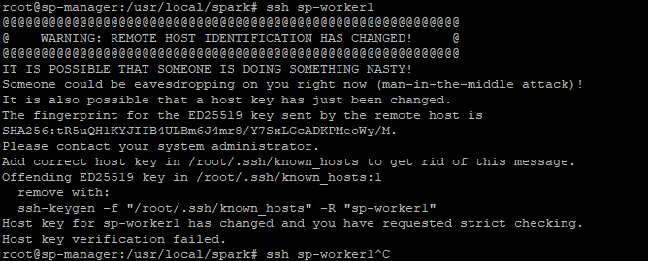

Solution: from manager container run below commands

$ ssh-keygen -R sp-worker1

$ ssh-keygen -R sp-worker2